Artificial intelligence

# Report

**Project Title:**

* Unlocking Heart Health: Predictive Insights into Cardiac Wellness

# Date:

* May 6, 2024

# Course:

* AI

# TABLE OF CONTENTS

Introduction/Executive Summary 4

Methodology 4

Experimental Simulation 5

Results and Technical Discussion 5

Conclusions 6

References 6

Appendix: Project Source Codes 7

## Introduction/Executive Summary

* + Welcome to our presentation on "Unlocking Heart Health: Predictive Insights into Cardiac Wellness." In this session, we will delve into a groundbreaking project aimed at predicting the risk of heart disease using advanced data analytics and machine learning techniques. Let's embark on a journey to explore how technology can revolutionize the way we approach cardiovascular health.
  + Heart disease remains a leading cause of mortality worldwide.
  + Early detection and prevention are crucial challenges.
  + Traditional methods often rely on clinical assessments and invasive procedures.
  + Our project develops a predictive model for heart disease risk assessment.

## Methodology

* Machine learning algorithms for risk prediction
* Logistic regression chosen for simplicity and interpretability
* Data preprocessing to handle missing values and categorical variables
* Feature engineering to select relevant features
* Model training and evaluation using accuracy, precision, recall, and F1-score
* Hyperparameter tuning for improved performance
* Cross-validation for generalizability
* Our methodology describes the development of our heart disease prediction model. We explored various machine learning algorithms and selected logistic regression for its effectiveness in binary classification tasks. Data preprocessing ensured data quality, and feature engineering focused on selecting the most relevant factors for predicting heart disease. The model was trained and evaluated using various metrics, and hyperparameter tuning optimized its performance. Cross-validation techniques ensured the model's generalizability to unseen data.

## Experimental Simulation

* Programming language and environment (e.g., Python)
* Implementation of primary function and procedures
* Test cases for different scenarios
* Setting program parameters and constants.
* This section details the experimental simulation process. We specified the programming language and environment used to develop the model. The primary function and procedures of the algorithms were implemented, and we designed test cases to evaluate the model's performance under various scenarios. Finally, we established program parameters and constants to ensure consistency and proper execution.

## Results and Technical Discussion

* Main program results and outputs
* Performance evaluation metrics (accuracy, precision, recall, F1- score)
* Discussion of results and quality
* Feature importance analysis for key risk factors
* We present the main results and technical discussion in this section. Here, we report the program's outputs and evaluate its performance using metrics like accuracy, precision, recall, and F1-score. A detailed discussion on the results and their quality is included. Furthermore, we analyze feature importance to identify the key factors that significantly influence heart disease prediction.

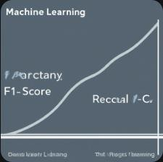

## Conclusions

* Recap of project goals and achievements
* Limitations of the current model
* Recommendations for future work
* The conclusion section summarizes the project's goals and accomplishments. We acknowledge the limitations of the current model and provide recommendations for future research and development. Here, we can discuss potential improvements in data sources, exploration of advanced machine learning techniques, and the importance of continuous validation and testing.

## References

* Data sources:

<https://www.kaggle.com/datasets/volodymyrgavrysh/heart-disease?rvi=1>

* Articles and research:

<https://towardsdatascience.com/heart-disease-prediction-73468d630cfc>

* Sklearn documentation for data analysis:

<https://scikit-learn.org/stable/documentation.html>

## Appendix

**Agent Source Code Github link:**

[**https://github.com/NOUR12321/NOUR_Codes/blob/69cf99f4335d109e4ae39fe6a40708cae956576a/heart_model(source%20code).ipynb**](https://github.com/NOUR12321/NOUR_Codes/blob/69cf99f4335d109e4ae39fe6a40708cae956576a/heart_model(source%20code).ipynb)

**GUI source code Github link:**

[**https://github.com/NOUR12321/NOUR_Codes/blob/9ee8378a6b7843800928c8339584daea6fba2c1b/GUI_Heart_diseases.py**](https://github.com/NOUR12321/NOUR_Codes/blob/9ee8378a6b7843800928c8339584daea6fba2c1b/GUI_Heart_diseases.py)

# Agent Code snippets:

# Libraries :

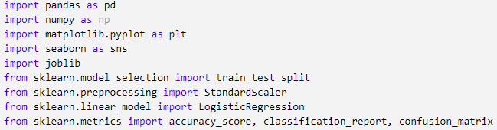

# Load the dataset :

# 

# 

# Exploratory Data Analysis(EDA):

# 

# Visualizing the target variable distribution:

# 🡪

# 

# Visualizing correlation matrix:

# 🡪

# 

# Data preprocessing:

# 

# Splitting the dataset into training and testing sets:

# 

# Feature scaling:

# 

# Building the Logistic Regression model:

# 

# 

# Making predictions:

# 

# Evaluating the model:

# 

# 

# Classification report:

# 

# 

# Confusion matrix:

# 

# 

# Data to predict:

# 

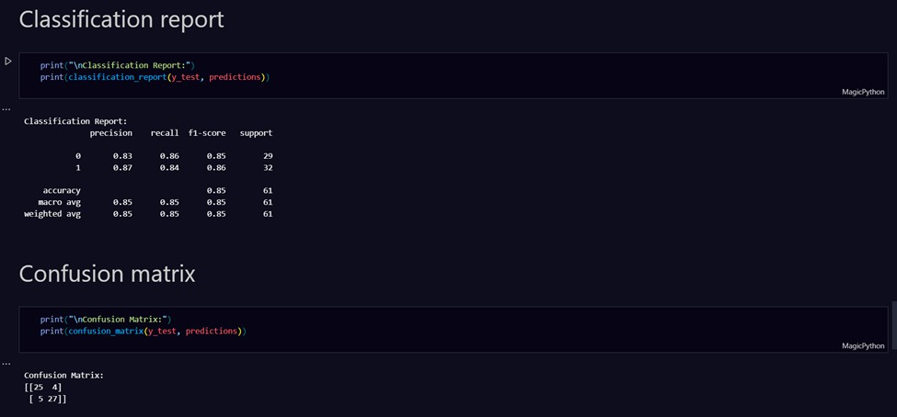

I hope this report meets your expectations!